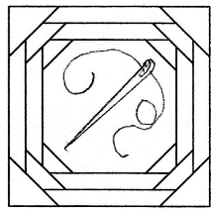
Flying Needles Quilters’ Guild
P.O. Box 691
Woodland, CA 95695
www.flyingneedlesyolo.org
flyingneedlesyoloco@gmail.com

RE: Affiliate Membership with Flying Needles Quilters’ Guild

Dear Owner,

We would like to offer you the opportunity to renew your affiliation or become a new affiliate member of our Flying Needles Quilt Guild for the year beginning July 1, 2020. We are a very active guild with over 100 members. The fee is $40.00 per year, payable to FNQG at the above address. Membership provides you with a advertisement in our newsletter sent to our membership as well as an ad on our web site http://www.flyingneedlesyolo.org that can be viewed by anyone searching for quilt guilds and to encourage our members to support our affiliates.

You would also be supporting our charitable efforts to provide quilts for such groups as Linus, Ronald McDonald House, a hospice group at Woodland Hospital, and others. We also create doggie beds for Rotts of Friends Animal Rescue.

If you would like to update your information, please fill in the following:

Business Name: ________________________________________

Address: ______________________________________

Phone Number: _________________________________

Contact Name: ________________________________________

Email: ________________________________________

Website: ______________________________________

Warm regards,
Myrna Hays
Affiliate Chairperson

